**Name: Mostafa Mabrouk Mohammed Mosa**

**B.N/ 923**

**25/5/2020 Date/**

**Topic: Operating Systems**

**Github-Link :** [**https://github.com/engmostafa/HTML-PROJECT-REPOSITORY**](https://github.com/engmostafa/HTML-PROJECT-REPOSITORY)

**Application Brief** :

An operating system is a program that interfaces the end-user with computer hardware. The kernel is the central component of computer operating systems. The kernel is only responsible for maintaining the software / hardware communication. Two most popular kernels are Monolithic and Micro Kernels. Process, Device, File, I/O, Secondary-Storage, Memory management are various functions of an Operating Systems. Batch, Multitasking/Time Sharing, Multiprocessing, Real Time, Distributed, Network, Mobile are various types of Operating Systems. Operating systems aim mainly at implementing and facilitating user programs. In addition to the hardware framework, different programming systems are used for this function. An OS is a program that manages and controls a complete set of applications.

Operating systems provide a platform for other programs that are called applications. These apps help users easily accomplish a particular task. This acts as a computer-user interface. It is designed so that various applications are operated, controlled and executed on the computer. One of the tasks of operating systems:

It is used to transfer programs from / to memory. It allows the user to save files to the backup store. It provides the interface between the user and the computer, for instance, Windows Vista and Apple OSX. This processing time is organized by programs.

An OS operates on the same principles on a larger machine like a mainframe.

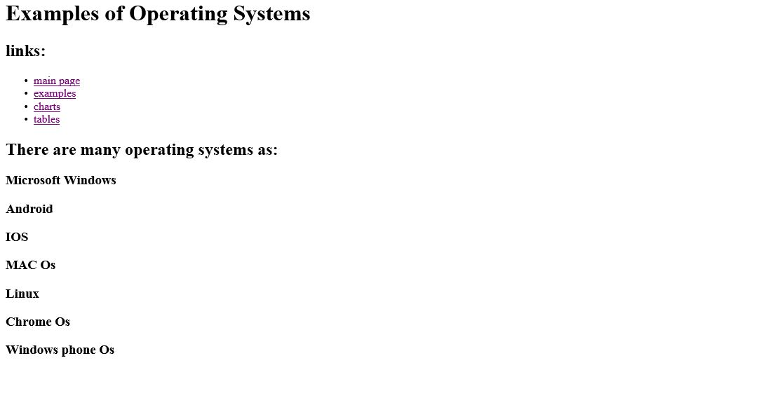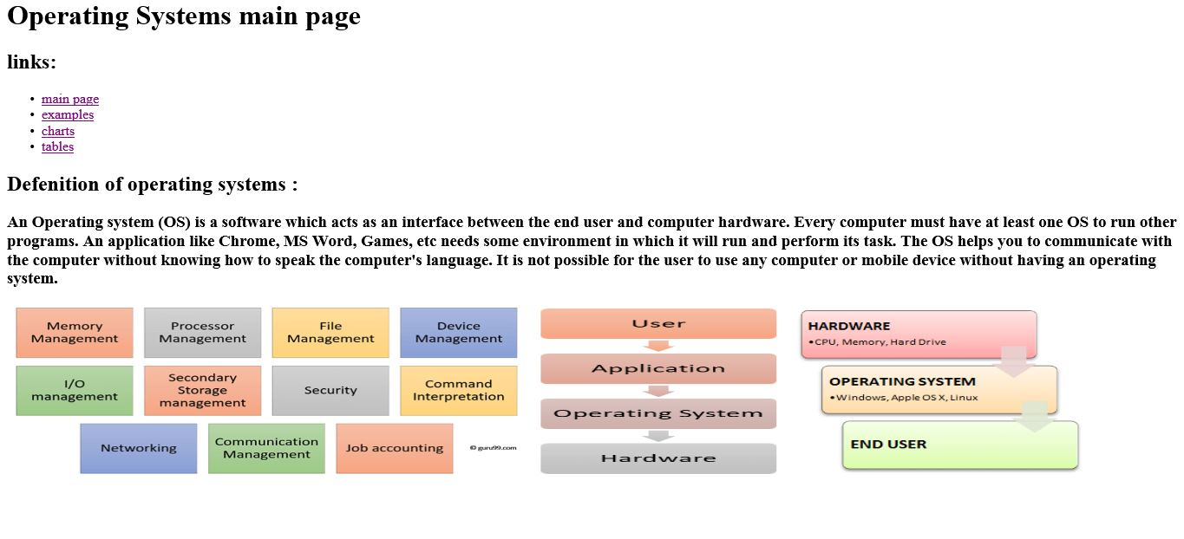**Screen-Shots :**

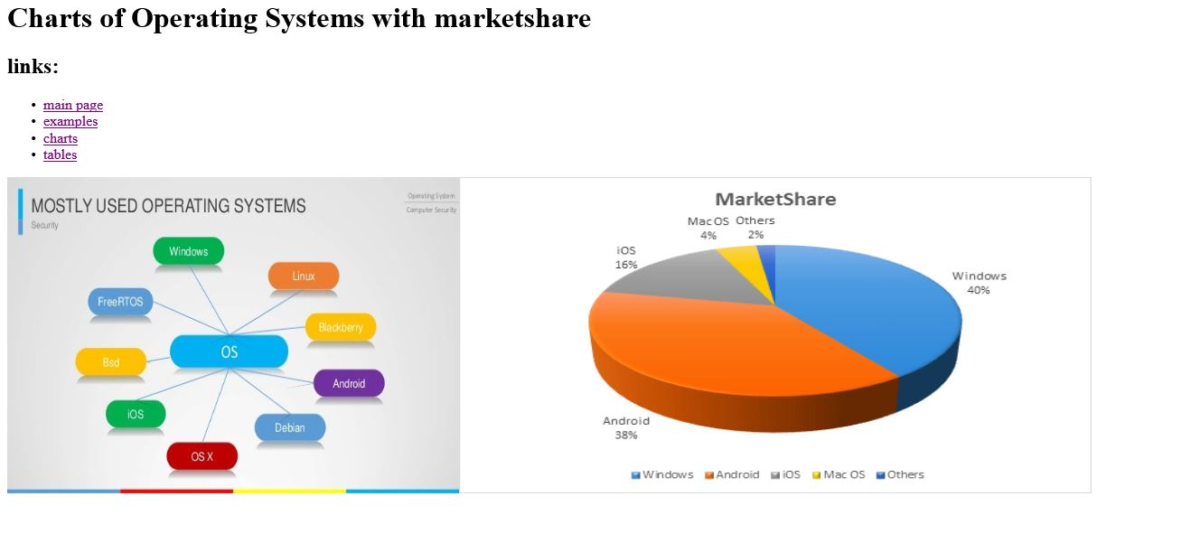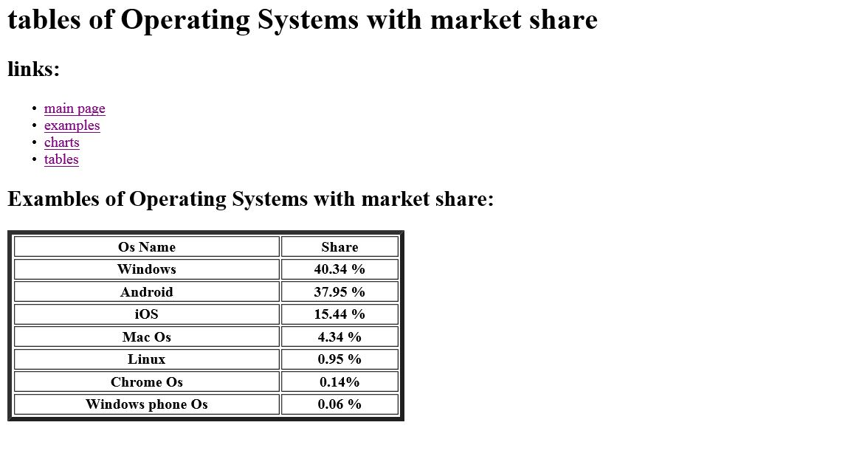

**Source code :**

